National Survey Data Analysis Report

Introduction

Throughout this data analysis, my ambition is to find out if depression influences young men to have unhealthy practices such as low physical activity and smoking. Also, I would like to identify which age group is affected the most by cigarettes. When you are depressed, the well-being of your body and mind are interconnected and reliant on one another. When your body feels unwell, your mood and mental capabilities are inflicted; likewise, mental health dramatically impacts the physical health of your body. Depression affects how your body and mind feel and respond to everyday life. With the execution of my data analysis, I will be able to confidently say that the statements I have provided above are factual.

Data Source

This data was taken from the National Health and Nutrition Examination Survey. This survey was taken during the years of 2015-2016 across the United States. Each study that I have included in my analysis used the stratified sampling strategy to select its participants . Data for the DPQ study was collected at the Mobile Examination Center (MEC) during the MEC Interview. Data was also taken from questions that were asked by experienced interviewers utilizing the Computer-Assisted Personal Interview (CAPI) system. Data for the PAQ study were collected from the homes of participants who were aged 2-11 or older than the age of 16 by trained interviewers. They used the Computer Assisted Personal Interview (CAPI) system to collect this data. For responders aged 12 to 15, PAQ was asked in the Mobile Examination Center (MEC). Data for the SMQ study were collected from the homes of participants who were 18 years or older by trained interviewers. They used the Computer Assisted Personal Interview (CAPI) system to collect this data. For responders aged 12 to 17, SMQ was asked in the Mobile Examination Center (MEC). Data for the DEMO study was collected by using the Computer Assisted Personal Interview (CAPI) system. The target population for the ALQ study was adults aged 18 or older. This allows researchers to collect data from the population that is at risk of alcohol usage . The target population for the DPQ study was US citizens who were 12 years or older. Unfortunately, only data from participants aged 18 and older are contained in this data file due to limitations. Participants demanding a proxy were not qualified because of the sensitiveness of the questions. Data for youth aged 12 through 17 years are accessible through the NCHS Research Database only. Targeting this population allows the researcher to identify a broad range of residents who shows symptoms of depression. The target population for the PAQ study were US citizens who were two years or older. Statistically majority was offered to participate in physical activities as young as two years of age. The target population for the SMQ study was US citizens aged 12 years and older. For participants who were aged 12-17 years, there were no proxy interviews. Questions were restricted to youths 12-17 years; this caused variables to have different sample populations. This target population was beneficial for this study because, statistically majority were shown to have had their first smoking experience by the age of 15. The target age groups for demographic variables in the DEMO file were altered by topics. To collect the data that I needed for this analysis, I precisely chose different variables and values to observe. For this data analysis, I will investigate the influence depression has on young men. Does it encourage them to smoke, or does it discourage them from exercising? Also I plan to be able to identify which age group is affected the most by cigarettes. After examining the different data files and merging them , I dropped all female observations and those who were not experiencing depression. This way, I will only be able to observe necessary participants who can help me answer my research question.
Variable description | Variable name | Data type (values) | Measurements
In a typical week, on how many days do you partake in moderate-intensity sports, fitness, or recreational activities? | ` PAQ670 | Continuous (1-7) | Based on questionnaire results
Do you now smoke cigarettes? | SMQ040 | Categorical (every day, some days, not at all, Refused, Don't know, Missing | Based on questionnaire results
[Over the last 2 weeks, how often have you been bothered by the following problems:] feeling down, depressed, or hopeless? | DPQ020 | Categorical ( Not at all, Several days, More than half the days, Nearly every day, Refused, Don't know, Missing) | Based on questionnaire results
During the past 30 days, on the days that smoked, about how many cigarettes did you smoke per day? | SMD650 | Continuous (1, 60) | Based on questionnaire results
The physical activity status of participants  Low Physical Activity | LPA | Categorical (low, normal) | Based on questionnaire results
Did participant smoke cigarettes | SMOKE | Categorical (yes, no) | Based on questionnaire results
Gender of participant | RIAGENDR | (Categorical(Male,Female) | Based on questionnaire results
Age of participant | RIDAGEYR | Continuous (18,80) | Based on questionnaire results

Table 1 Continuous variables
Variable name | N (non-missing) | NMISS (# missing observation) | MIN value | Max Value | Mean | Median | Std Deviation
SMD650 | 1039 | 4695 | 1 | 60 | 10.40 | 10 | 8.52
PAQ670 | 2347 | 3388 | 1 | 7 | 3.52 | 3 | 1.78
SMD650 | 39 | 910 | 1 | 20 | 7.49 | 5 | 6.06
PAQ670 | 60 | 63 | 1 | 7 | 3.58 | 3 | 1.72
RIDAGEYR | 5735 | 0 | 18 | 80 | 48.05 | 48 | 18.43
RIDAGEYR | 123 | 0 | 18 | 30 | 23.48 | 23 | 3.81

Table 2. Categorical variables
Variable name (no missing, % percent missing) | Categories | Number of respondents in each category and (%)
DPQ020 (571, 44%)  (0,0%) | Not at all | 3920(75.9%)  (0,0%)
 | Several Days | 872(16.89%)  90(73.17%)
 | More than half the days | 210(4.07%)  23(18.70%)
 | Nearly everyday | 159(3.08%)  10(8.13%)
 | Refused | 3(0.06%)  0(0%)
 | Don`t know | 0(0%)  0(0%)
SMQ040(3416,60%)  SMQ040(74,60%) | Every Day | 798(34.41%)  23(46.94%)
 | Some Days | 257(11.08%)  16(32.65%)
 | Not at all | 1264(54.51%)  10(20.41%)
LPA(3388,59%)  LPA 63(51%) | Low | 804(34.26%)  19(31.67%)
 | Normal | 1543(65.74%)  41(68.33%)
SMOKE(3416,60%)  SMOKE(74,60%) | Smoke | 1055(45.49%)  (39,79.59%)
 | Don`t smoke | 1264(54.51%)  10(20.41%)
RIAGENDR | Male | 2759(48.11%)  123(100%)
 | Female | 2976(51.89%)  0(0%)

Conclusion

In conclusion of this data analysis, I can confidently say that this report supports my predictions for this study. My first prediction was that depression leads to smoking, and my second prediction was that depression doesn't affect participants' exercise. After creating a bar graph to display the relationship between depression and smoking. I became aware that 79.59% of depressed young men in my study smoked cigarettes compared to 10(20.41%) that didn't smoke at all. This shows me that most young men tend to lean on smoking cigarettes whenever they feel down or depressed.
To answer my second research question, I created a bar graph to display the relationship between depression and exercising. From a personal standpoint, I understand depression may discourage me from doing a lot of things, but whenever I am in that state of mind, I lean on exercising to clear my mind. This analysis showed me that I'm not the only one with that coping strategy. After observing this data distribution, I am now aware that 41(68.33%) depressed young men in my study had normal physical activity status compared to 19(31.67%) that had a Low Physical Activity status.

Performing this data analysis was very interesting and informative. In the process of answering my research questions, another inquiry formed. I created another research question that would allow me to precisely identify the age group cigarettes tend to impact the most. This research question follows, What age group is most affected by cigarettes? After creating a histogram to display reach questions, I became aware that most adults smoke in their mid 30's and early 60s. The numeric summary of this distribution is bimodal and right skewed with no outliers.
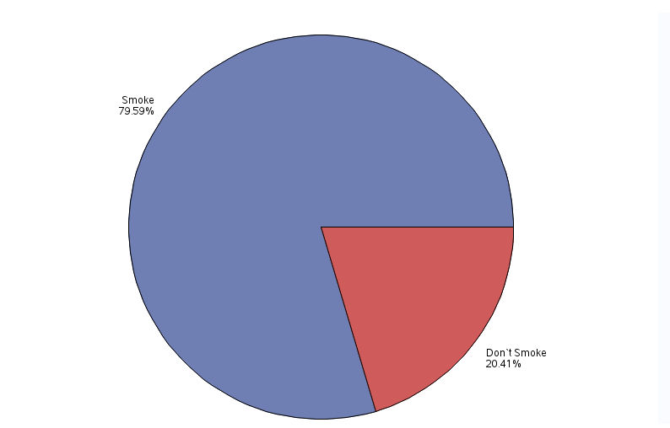
Smoke Status Distribution

Gender Distribution
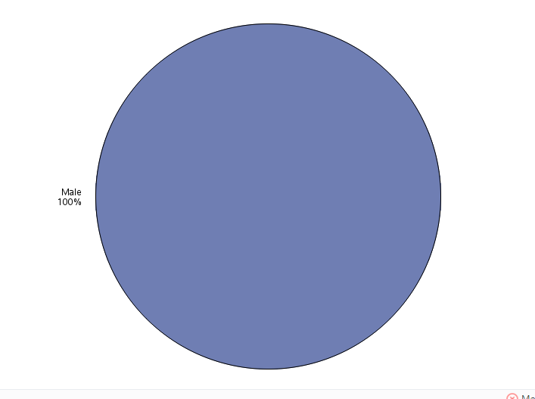

Smoke Frequency Distribution

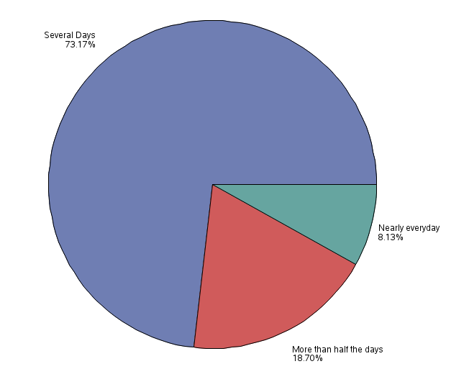

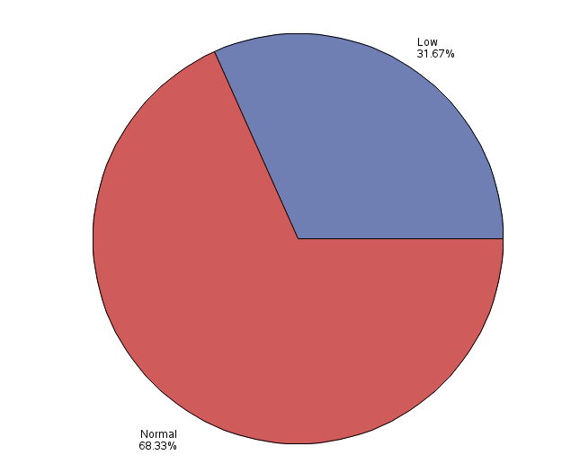
Distribution Of Physical Activity Status

